# Fill in Missing Values and Sum Values with Pivot Tables

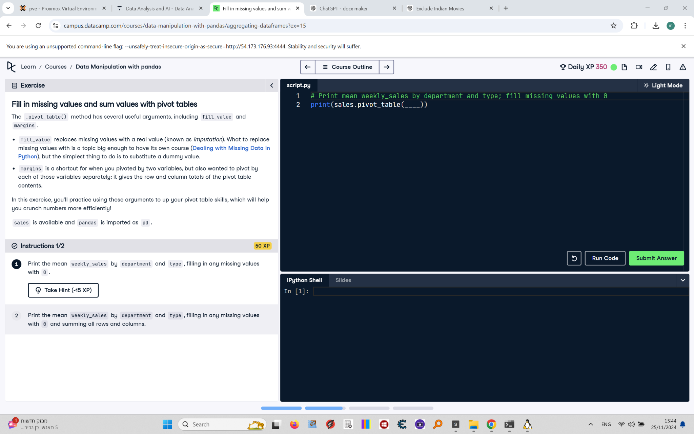

The .pivot_table() method has several useful arguments, including fill_value and margins.  
  
fill_value replaces missing values with a real value (known as imputation). margins is a shortcut for when you pivoted by two variables, but also wanted to pivot by each of those variables separately: it gives the row and column totals of the pivot table contents.  
  
In this exercise, you'll practice using these arguments to up your pivot table skills, which will help you crunch numbers more efficiently!  
  
sales is available and pandas is imported as pd.

## Final Answer - Instruction 1

# Print mean weekly_sales by department and type; fill missing values with 0  
print(sales.pivot_table(values="weekly_sales", index="department", columns="type", fill_value=0))